Six PGY1 residents across 5 unique practice sites. Each resident will have a home site for required learning experiences (internal medicine, critical care, emergency medicine, and administration) and staffing requirement. Residents will be able to complete up to 2 elective rotations (12 weeks) at another Legacy Health site. Elective experiences include: ambulatory care, transplant, infectious diseases, trauma critical care, cardiovascular critical care, pediatric critical care, pediatric and adult oncology, and neonatal critical care.
Residency Program Director: Michelle Murray, RPh, BCPS, FOSHP mmurray@lhs.org
Residency Program Coordinator: Katie Yabut, PharmD, BCPS kyabut@lhs.org

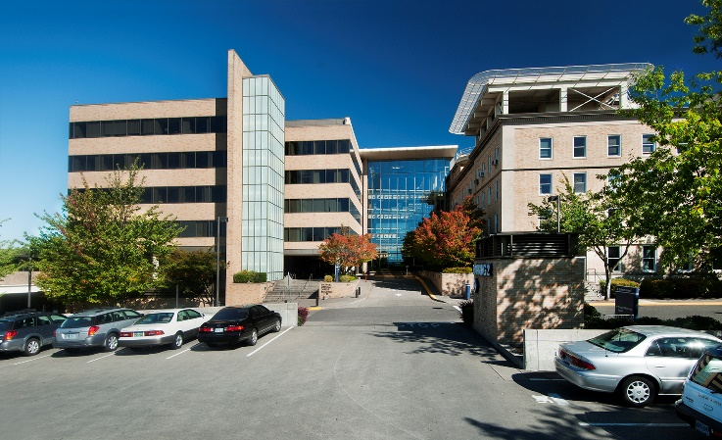
Legacy Emanuel Medical Center
(2 positions)
- Average census: 325 patients
- 29 pharmacists, 37 technicians
- Located in NE Portland
- Site Residency Program Coordinator:
  - Michelle Pfeifer PharmD, BCPS
mfpfeife@lhs.org
- NMS Code: 113121
- Elective Learning Experiences:
  - Neuro-Trauma Critical Care
  - Cardiovascular Critical Care
  - Transitions of Care
  - Infectious Diseases
  - Pediatric and Neonatal Critical Care
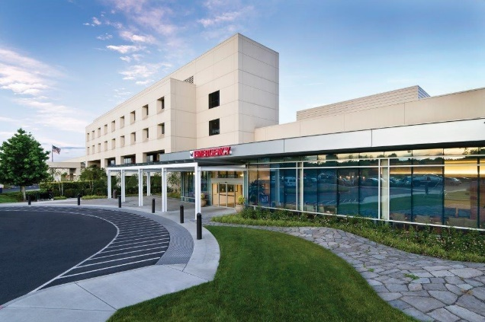
  - Pediatric Oncology
Legacy Mt. Hood Medical Center
- Average census: 70 patients
- 16 pharmacists, 8 technicians
- Located in Gresham (East of Portland)
- Site Residency Program Coordinator:
  - Uriel Jimenez Sanchez PharmD, BCPS
ujimenez@lhs.org
- NMS Code: 113124
- Elective Learning Experiences:
  - Transitions of Care
  - Ambulatory Care
  - Anticoagulation

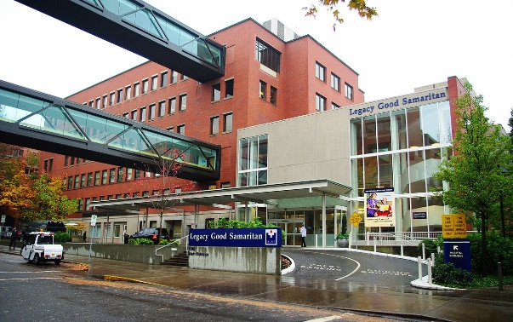
Legacy Good Samaritan Medical Center
- Average census: 140 patients
- 29 pharmacists, 22 technicians
- Located in NW Portland
- Site Residency Program Coordinator:
  - Eva Levbarg, PharmD, BCPS
elevbarg@lhs.org
- NMS Code: 113113
- Elective Learning Experiences:
  - Renal Transplant
  - Adult Oncology
  - Operating Room
  - Transitions of Care

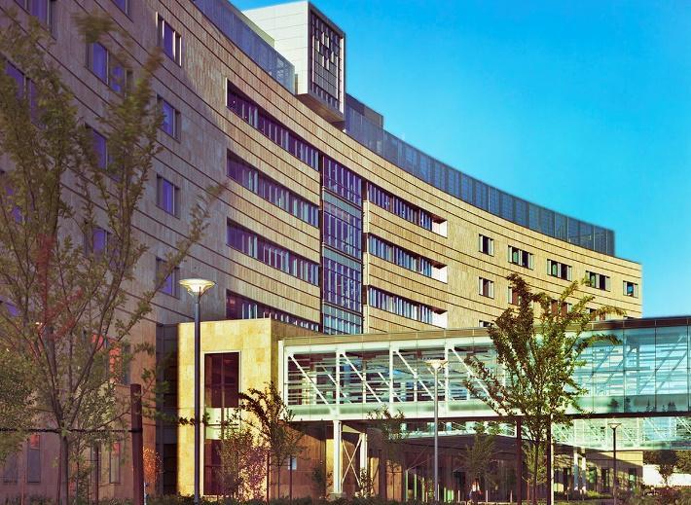
Legacy Salmon Creek Medical Center
- Average census: 175 patients
- 26 pharmacists, 22 technicians
- Located in SW Washington (Vancouver, WA)
- Site Residency Program Coordinator:
  - Franklin Phan, PharmD
frphan@lhs.org
- NMS Code: 113122
- Elective Learning Experiences:
  - Oncology Ambulatory Care
  - Anticoagulation

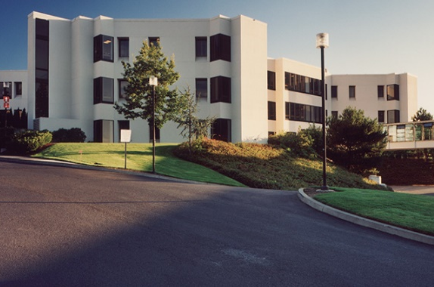
Legacy Meridian Park Medical Center
- Average census: 100 patients
- 17 pharmacists, 11 technicians
- Located in Tualatin (South of Portland)
- Site Residency Program Coordinator:
  - Sean Ottum, PharmD
sottum@lhs.org
- NMS Code:113123
- Elective Learning Experiences:
  - Anticoagulation

